Lab 6 – Regression Analysis
Student: Toleubek Assiya
ID: 23B150271

1. Exploratory Data Analysis
- Summary statistics, histograms, scatter plots
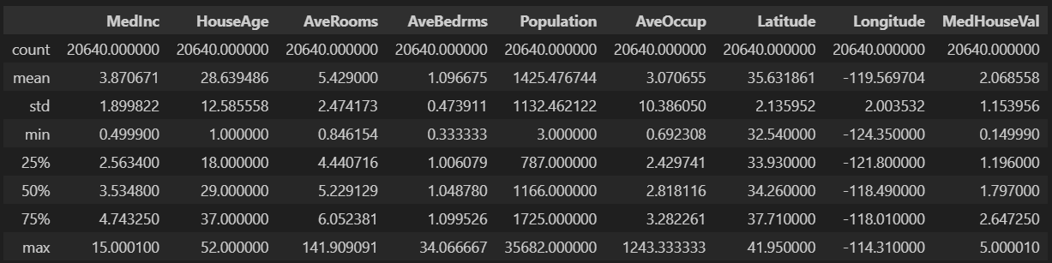
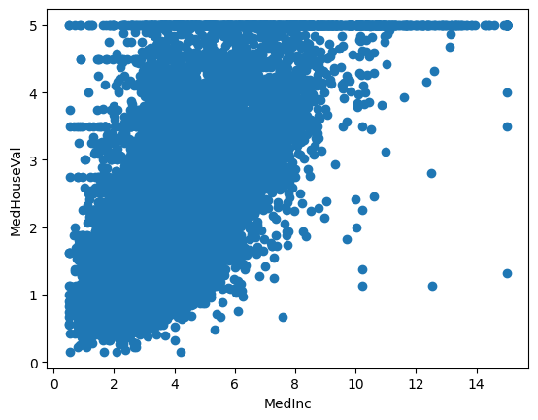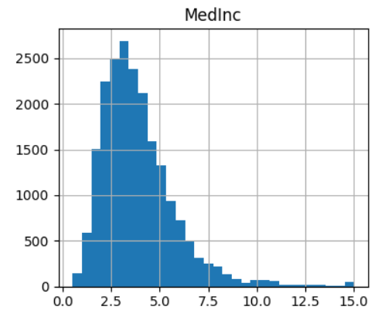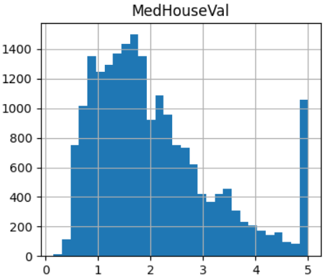
Histograms revealed that several variables, including MedHouseVal and MedInc, are slightly right-skewed. The target variable also has an upper cap at 5.0, which may affect the regression results.
- Correlation matrix with target
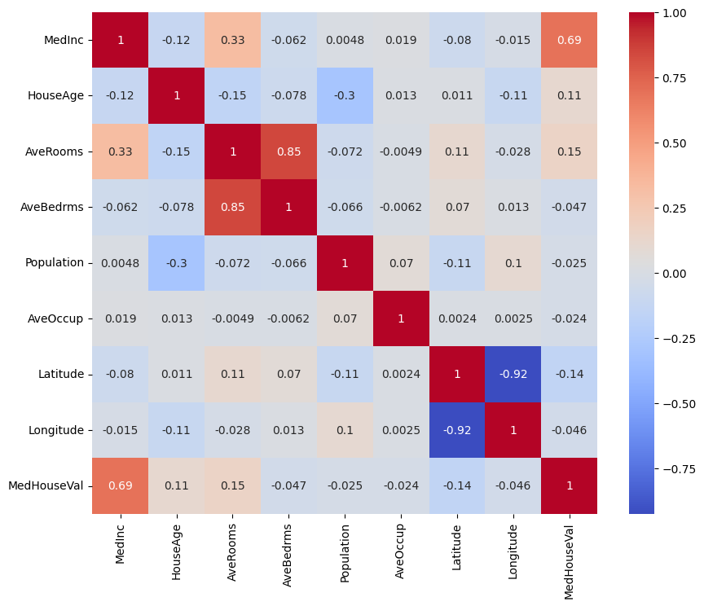
The correlation matrix confirmed that MedInc has the highest correlation with MedInc (0.69), while some predictors such as AveRooms and AveBedrms are highly correlated with each other (0.85), suggesting potential multicollinearity.
2. Build a Multiple Regression Model
- Use all predictors initially
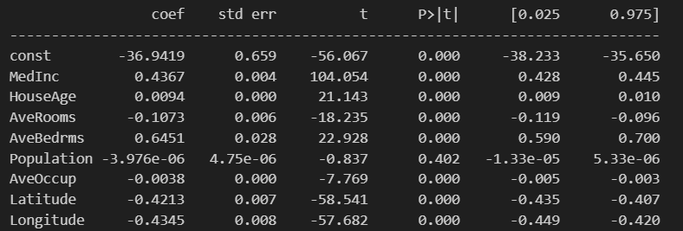
The model explains 60,6% of the variation in house prices (R² = 0.606). Most predictors are statistically significant (p < 0.05), except for Population (0,402). Median income is the strongest predictor of house prices. The large condition number suggests possible multicollinearity.
- Check VIF for multicollinearity
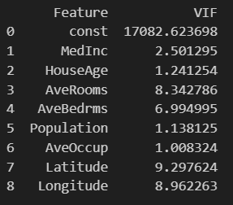
Average Rooms and Average Bedrooms likely highly correlated, consider removing or combining one. Latitude and Longitude show geographic multicollinearity

3. Model Refinement
- Remove or combine highly correlated predictors
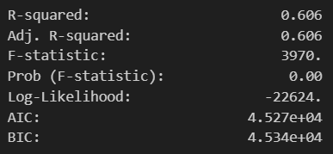
The drop in R² (0.606 vs 0.596) is minimal, so the model still explains almost the same variance in house prices. The increase in AIC is small,so the model is slightly less optimal in terms of fit, but simpler and easier to interpret

- Consider transformations (log of target?)
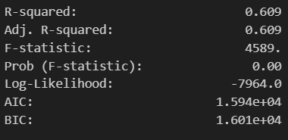
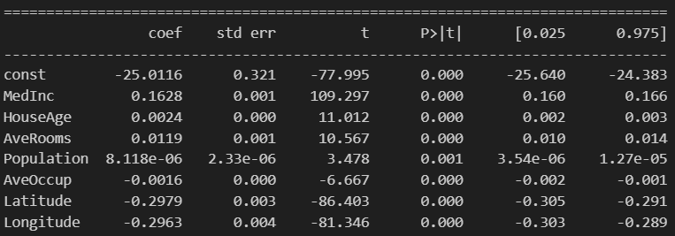
Applying a log transformation to the target helps reduce skewness and heteroscedasticity, making the model more stable
- Check residuals – are assumptions met?
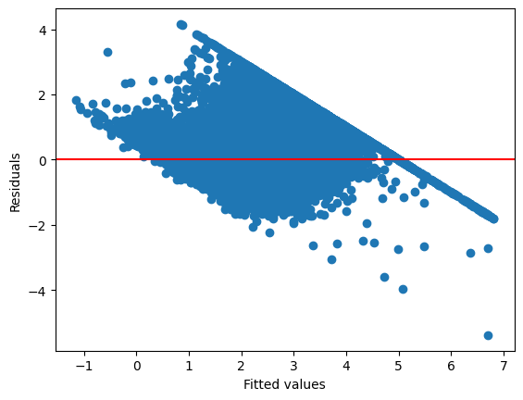
The residuals show a clear downward trend, indicating that the model does not fully capture the relationship in the data. A transformation of the target or additional features may be needed

4. Interpret Results
- Which factors significantly affect house prices?
MedInc - strong positive effect on house price (coef=0.3701)
Latitude & Longitude - significant negative effects, indicating location strongly influences price (coef=-0.45 and -0.46)
- Interpret coefficients in real terms
MedInc - each additional $10,000 in median income increases house price by $3,701 (depending on model)
HouseAge - each additional year adds $9–$10 to price.
AveRooms- each additional room increases price by $17 (refined model).
Latitude and Longitude- moving north or east generally decreases house price.
AveOccup -more people per household slightly decreases price.
- How well does your model explain price variation?
R-squared = 0.596–0.606, so the model explains about 60% of the variance in house prices.
AIC=45270–45780, refined model slightly simpler, minor loss in fit but reduced multicollinearity.
Overall, the model captures the main patterns but there’s residual variance, likely due to missing predictors or non-linear effects.

5. Predict for New Data
- Use train/test split
- Report test R² and RMSE
0.576 - the model explains about 57.6% of the variance in house prices on unseen data.
0.746 - on average, the model’s predictions are off by $74,600 per house.

